aqaurius plumbign & heating qr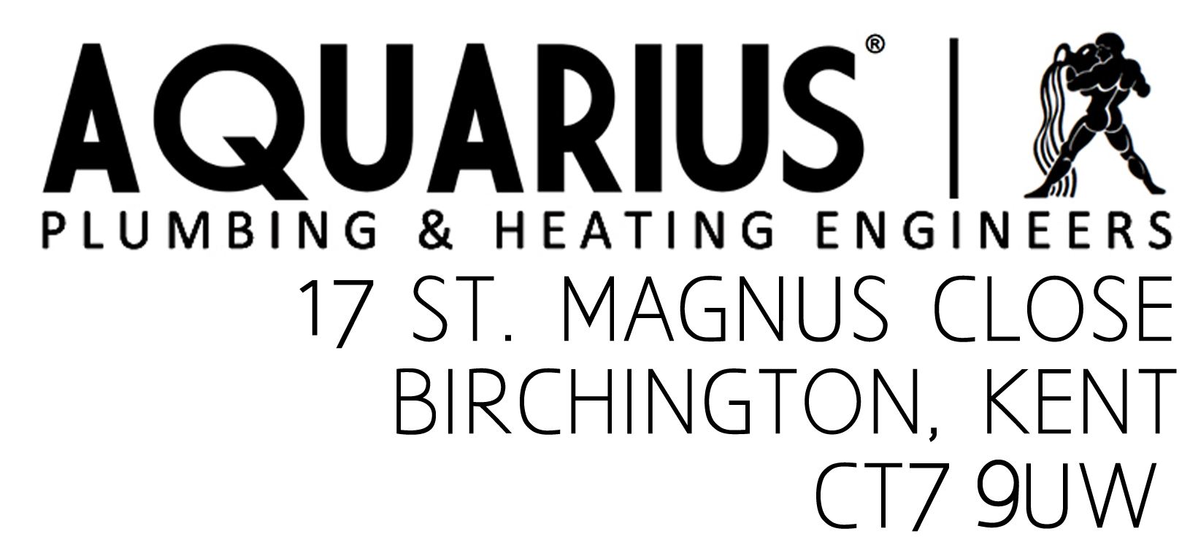

**Provision of Services Regulations Information**

**Name:** Aquarius Plumbing & Heating Engineers.

**Service:** Plumbing and heating installations, services, repairs & gas certification.

**Registered office and postal address:** As above

**Telephone:** 01843 841589 / 07989 600542

**Email:** [enquiries@aquariusplumbingamdheating.co.uk](mailto:enquiries@aquariusplumbingamdheating.co.uk)

**Regulating body:** Gas Safe registered, no. 200275

**General terms and conditions:** A letter of engagement accompanied by our standard terms and conditions will be provided at the start of any contract for works.

**Applicable law:** Unless otherwise agreed, English law, with the English courts having exclusive jurisdiction in relation to any claim, dispute or difference concerning the service and any matter arising from it.

**Work Guarantees:** All works guaranteed for 3 months from date of completion, this covers parts and labour, please see our full guarantee document for further information. Boilers are also subject to a specific manufacturer’s warranty, details of which will be provided on request. Your statutory rights are not affected by our guarantee.

**Complaints:** Complaints can be made by contacting Steve Simpson at the above address.

Gas Safe also operate a complaints procedure and you can access this by visiting [www.gassaferegister.co.uk](http://www.gassaferegister.co.uk) or by calling 0800 4085500



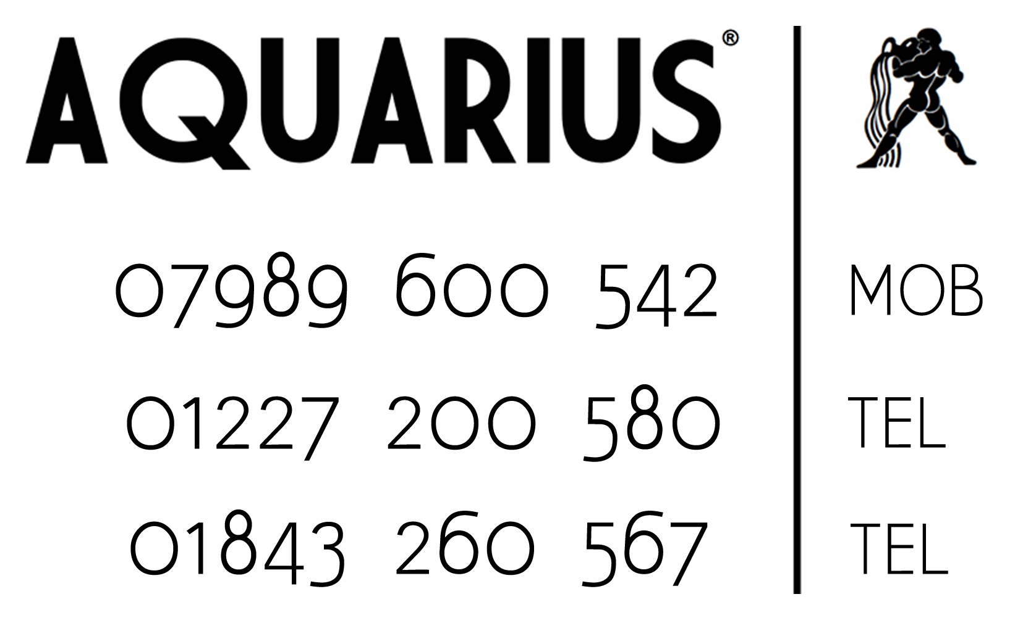

**200275**